PERSONAL DETAILS
Somnath Sengupta. 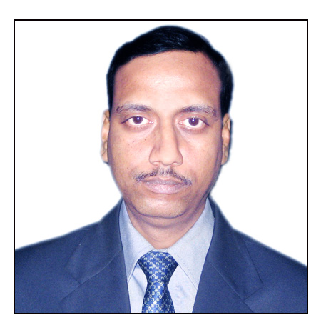
B-23/303, Larica Township,
Barasat Barrackpore Road
Barasat, North 24 Parganas
Kolkata – 700126, W.B.
India.
Mobile: +91-9971500371
+91-7908343211
e-mail: somsen1969@gmail.com
sen.bobby80@yahoo.com

Career Objective:

In the competitive and globalized environment, I want to utilize my communication skills, working experience and dynamic efforts to achieve the organizational as well as personal goal.

Academic Qualification:

- X th from Bankura Zilla School in 1984 (Under West Bengal Board of Secondary Education).
- XII th from Bankura Zilla School in 1986 (Under West Bengal Council of Higher Secondary Education).
- Graduation (Honours) in 1990 from Bankura Christian College (Under the University of Burdwan).
- Post Graduate from NIIT Calcutta in 1993 in Systems Management in Computer Software.
Professional Qualification:

- One Year Diploma Course in Still Photography in 1990-91 from Bangiyo Bijnan Parishad, Calcutta and one Month Course in Digital Still Photography.

Skills in Computer:

Operating systems: MS-DOS, Windows XP Professional, Windows 10
Packages Known: Tally 4.5 & 5.4, Tally 9.0 and Tally ERP 9 & Tally Prime, Yatra Accounting package. Operating Tally ERP 9 since 2010 in single user and experience in working cloud computing.

Other Applications: MS-Excel, MS-Word, Photoshop 7.0, Knowledge of
Internet, e-mail, Scan, Fax, Photocopy etc other office related works.

Page: 02

Work Experience:

- Worked with American Express Bank at New Delhi from April 1994 to Sept 1994 as Accounts Assistant.
- Worked with Inter Globe Air Transport Limited (A GSA Co.) as an Accountant from September 1995 to August 2000 in revenue section of accounts department.
- Worked with AVS Travels and Tours Pvt. Ltd. (An IATA Co.) as Accountant from September 2000 to March 2007.
- Working with Ventours Aviation Pvt Ltd., as a Finance Controller and from 15th May 2007 to till Date.

Responsibilities:

- Handling Cash, Bank Operations for all online and offline banking works, Voucher Entries, Invoicing etc.
- Correspondence with different Foreign Airlines, Five Star Hotels and Transport Co.
- Checking of all five-star hotel bills, transporters bills, guide/escort bills and making their payments.
- Book Keeping (Cash, Bank, Payment and receipt etc.)
- Works related to foreign Exchange and Remittance etc. inward and outwards both
to other countries like Nepal, Sri Lanka, UK etc.
- Making of Trial Balance and Finalizing of Balance Sheet,

Tax Related Work Experiences:

- TDS Calculation for monthly deposit, Online TDS Deposit, TDS quarterly Return, GSTR-1, GSTR-3B, (2A,2B Reconciliation for input credit), making of GST Sale and Input credit Statement in Excel sheet. GST PAYMENT etc. Advance tax
Tally Operations:

I have been working in Tally software from 2007 onwards and currently working in Tally Prime latest version on cloud environment. Working with multiuser environment in Tally and send data to Mumbai H.O.

Strength:

- Positive Attitude, Ready to learn new things, Dedicated to work and hard working.
- Well versed with Computer Operations and can manage any difficult situation.

Area of Interest:

- Interacting with people and Strong desire to serve people.
- I have more than twenty-seven years of experience in accounts and Finance.
- Want to work with service industry or any other.

Page: 03

Current Designation and Resposnibilities :

Working as Finance Controller and looking after three division of Ventours as Finance Head

Personal Data :

Father’s Name : Dr. Dipak Kumar Sengupta.

Mother’s Name : Mrs. Malobika Sengupta.

Nationality : Indian

Religion : Hinduism

Date of Birth : 1st August 1969

Passport Number : U6085650, Place of Issue: New Delhi, India.

Proficiency : English, Hindi, Bengali

Mother Tongue : Bengali

Height : 5ft 09 inches

Weight : 72 kgs

Complexion : Whitish

Hobbies : Photography, Reading and Classical Music/Dance

Driving Lince No. : 41822/PRV/2000 Valid Up to – 01-06-2029

Family Back Ground : My Father is a Retired Govt. Servant from B S Medical College, Bankura & Mother is a House Wife.

I here by declare that all the above information is correct to the best of my knowledge and belief.

Date: 11th Nov 2021

Place: Kolkata - 700126 (Somnath Sengupta)

